
PATTERN DETECTOR SPEC

Pattern Detector Block Specification

CONTENT
Pattern Detector Block Specification 1
1. Overview 1
2. Block Diagram 1
3. Interface Specification 2
4. Functional Description 3
4.1 Operation Modes 3
4.2 Pattern Detection Algorithm 3
5. Performance Specifications 4
5.1 Throughput 4
6. Reset Behavior 4

1. Overview

The Pattern Detector block is designed to monitor two 64-bit data streams and detect when they contain the same 32-bit pattern. The block operates in two distinct modes: full adjustment mode and mask-based mode. When a pattern match is detected according to the active mode's criteria, the block asserts an output signal.

2. Block Diagram

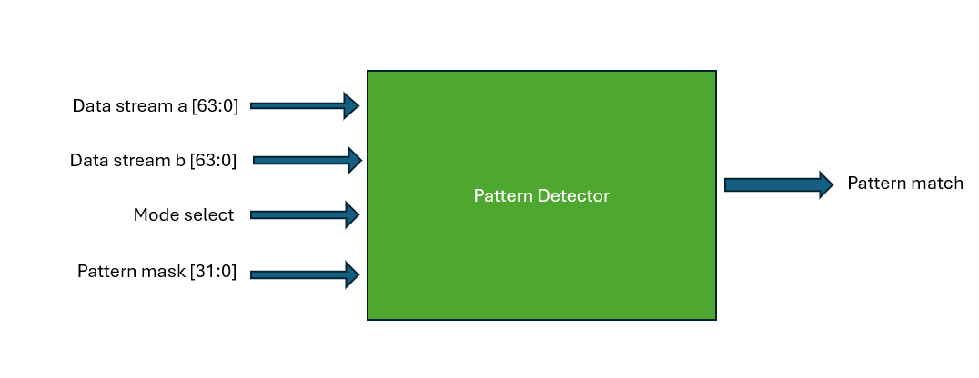

3. Interface Specification

Signal Name | Direction | Width | Description
clk | Input | 1 | System clock – 160 MHz
rst_n | Input | 1 | Active low reset
data_stream_a | Input | 64 | First data stream to be monitored
data_stream_b | Input | 64 | Second data stream to be monitored
mode_select | Input | 1 | Mode selection: 0 = Full adjustment mode, 1 = Mask-based mode
pattern_mask | Input | 32 | Bit mask for mask-based mode comparison
pattern_match | Output | 1 | Asserted when a pattern match is detected according to the active mode

4. Functional Description

4.1 Operation Modes

4.1.1 Full Adjustment Mode (mode_select = 0)
In this mode, the block searches for any identical 32-bit pattern within both 64-bit data streams. The block performs a sliding window comparison across all possible 32-bit alignments within the 64-bit streams.
The block will assert the pattern_match signal when it finds any 32-bit sequence that appears in both data streams, regardless of position.

4.1.2 Mask-Based Mode (mode_select = 1)
In this mode, the block uses the provided 32-bit pattern_mask to determine which bits should be considered during comparison. Only the bits where the corresponding mask bit is '1' will be compared between the two data streams.
The comparison is performed on all possible 32-bit alignments within the 64-bit streams, but only considering the bits specified by the mask.

4.2 Pattern Detection Algorithm
- For each possible 32-bit window position in data_stream_a (33 possible positions):
  - Extract the 32-bit window from data_stream_a
- For each possible 32-bit window position in data_stream_b (33 possible positions):
  - Extract the 32-bit window from data_stream_b
- Compare the extracted windows according to the active mode:
  - Full Adjustment Mode: Compare all 32 bits directly
  - Mask-Based Mode: Compare only the bits where pattern_mask[i] = 1
- If any comparison results in a match, assert the pattern_match signal

5. Performance Specifications

5.1 Throughput
Parameter | Value | Unit | Description
Data Processing Rate | 64 | bits/cycle | The block processes 64 bits per data stream in each clock cycle
Maximum Throughput | TBD | Gbps | Maximum data throughput at target clock frequency
Pattern Detection Latency | 1-3 | cycles | Clock cycles required to detect a pattern match after data is presented

6. Reset Behavior
Upon assertion of the active-low reset signal (rst_n), the block will:
- Clear the pattern_match output to '0'
- Reset all internal comparison logic and state machines
- Be ready to begin pattern detection on the next clock cycle after reset is de-asserted

